Role Profile

Job Title: | Associate Consultant – Sustainability | Location: | NW UK Base / hybrid
 | 2023 APPOINTMENTS

JOB DESCRIPTION & INTRODUCTION

This is a broad Associate Consulting role, you will be early on in your sustainability career and be supporting senior team members on decarbonisation, ESG reporting assurance and sustainability strategies, helping clients towards net zero and engaging in the circular economy and social justice and wider sustainability.

Your role will extend to provide assistance in auditing, consulting, data gathering and interpretation, and report writing according to specific client sustainability briefs. The interfaces with clients are both strategic and operational and we deliver solutions that are practical and appropriate. There will also be involvement in marketing and social media activities.

As a highly experienced Team, we are committed to helping develop a sustainable world. We pride ourselves on our exemplary track record of designing innovative, sustainable and energy efficient solutions, that minimise the use of natural resources whilst helping clients achieve their sustainability ambitions. The successful candidate will join us at a crucial stage in our development and be a significant contributor to the growth of the firm. A competitive salary is commensurate with the role.

At Carbonbit, sustainability is embedded in our DNA and our purpose is to help the world be more sustainable and become a better place to live and work without fear of climate change, biodiversity loss or social injustice..

Our mission is to reduce our clients’ risks, improve their performance and help them innovate to meet the challenges of quality, health & safety, environmental protection and social responsibility. As we strive to build a team that looks like the world around us, we want our people to stay and grow when they join us. As part of our efforts to build trust and transparency we engage in and promote diversity, equity, and inclusion into our work and we aim to cultivate a sense of belonging and personal growth throughout the company.

Carbonbit allows you to make an impact doing work you can be proud of, contributing to a global mission to align with the Sustainability Development Goals using integrity and transparency as our guiding standards and helping to create a brighter future for current and future generations, and a safer and more equitable society for us all.

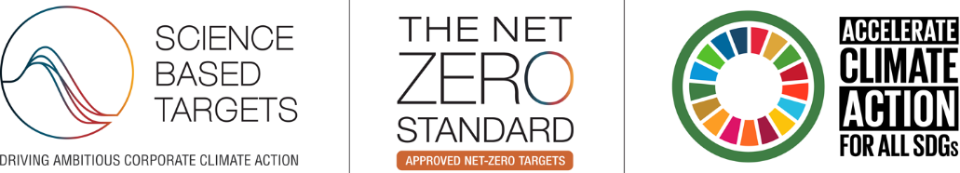

KEY RESPONSIBILITIES

- Provide support on multiple types of projects with a wide range of international clients, helping to shape processes and procedures as we continually evolve
- Support Consultants through research and development activities
- Help provide a first-class service to all clients and promote our company values
- Supporting the development and delivery of sustainable certifications, TCFD / TNFD and SBTi planning, ethical audits (SMETA), Net Zero Strategies, Circular Economy plans and associated ESG reporting
- Help coordinating frameworks, bids and sub-contractors
- Data analyses and data gathering for Scope 1, 2 and 3 GHG Inventories and energy related data through remote or physical site visits
- Be willing to pursue continual professional accreditation, training and development

KEY PERFORMANCE INDICATOR AREAS
- Communicate timely, accurate information and solutions
- Collaborate effectively with internal / external team members in a flat structure
- Be flexible and willing to take on a wide range of tasks and take a proactive approach to work
- Proactive approach to knowledge training and skills development

Person Specification
IDEAL KNOWLEDGE, SKILLS & ABILITIES

- A “can do” and positive attitude to all client communications and internal relationships and tasks
- Enjoys developing new concepts in collaborative environment
- A high level of oral, written and numeracy skills
- High level of appreciation around a customer focused service
- High attention to detail
- Knowledge of and interest in sustainability and Carbonbit
- Excellent attention to detail
- Able to support internal and external teams in meeting and often exceeding client expectations
- Dedicated and committed individual with a high degree of focus
- Highly flexible and adaptable to a wide variety of project requirements
IDEAL QUALIFICATIONS AND EXPERIENCE

- Hold at least a 2:1 at Degree and ideally a Master’s
- High level of commitment and an independent, conceptual working style
- Ability to quickly understand complex problems and develop / deliver solutions
- Willingness to travel/flexibility to work on international projects
- Ideally UK Resident with a Full Driving Licence

Please apply in writing with a CV and Cover Letter using the Web Form

