Role Profile

Job Title: | Consultant – Energy and Sustainability | Location: | NW UK Base / hybrid
 | 2023 APPOINTMENTS

JOB DESCRIPTION & INTRODUCTION

These are broad consulting roles, you will be responsible for consulting on wider decarbonisation, ESG reporting assurance and waste strategies, helping clients towards net zero and engaging in the circular economy and social justice.

Your role will extend to auditing, consulting on and implementing improvements to client operations. The interfaces with clients are both strategic and operational and we deliver solutions that are practical and appropriate.

As an extensive team, we are committed to helping develop a sustainable world. We pride ourselves on our exemplary track record of designing innovative, sustainable and energy efficient solutions, that minimise the use of natural resources whilst helping clients achieve their sustainability ambitions. We are recruiting for multiple roles. The successful candidates will join us at a crucial stage in our development and be a significant contributor to the growth of the firm. A competitive salary is commensurate with the role.

At Carbonbit, sustainability is embedded in our DNA and our purpose. Our mission is to reduce our clients’ risks, improve their performance and help them innovate to meet the challenges of quality, health & safety, environmental protection and social responsibility. Our goal is to build a team that looks like the world around us, and we want our people to stay and grow when they join us. As part of our efforts to build trust and transparency we engage in and promote diversity, equity, and inclusion into our work and we aim to cultivate a sense of belonging throughout the company.

Carbonbit allows you to make an impact doing work you can be proud of, contributing to a global mission to align with the Sustainability Development Goals using integrity and transparency as our guiding standards and helping to create a brighter future for current and future generations, and a safer and more equitable society for us all.

If you don’t believe you have the all the skills and experience required for these roles we are also recruiting graduates and post graduates into more junior but equally important roles, and we welcome speculative emails from great people.

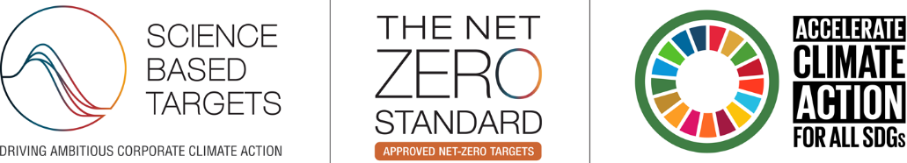

KEY RESPONSIBILITIES

- Help shape strategy for the services delivered to ensure that we remain at the forefront of the sustainability industry
- Further enhance existing very strong client relationships and promote / develop new and existing services to clients
- Responsible for delivery of sustainable building certifications, TCFD and SBTi planning, ethical audits (SMETA), Net Zero Strategies, Circular Economy plans and associated ESG reporting
- Coordination of frameworks, bids and sub-contractors
- Preparation of Scope 1, 2 and 3 GHG Inventories
- Foster an environment of innovation, customer service and continuous improvement
- Be willing to continue enhanced professional accreditation (CEnv), training and development

KEY PERFORMANCE INDICATOR AREAS
- Superb delivery of the services and projects resulting in the meeting of and wherever possible, exceeding client expectations
- Communicate timely, accurate management information and solutions
- Collaborate effectively with internal / external team members in a flat structure
- Provide regular opportunity analyses to help shape the company direction and strategy
- Help drive profitable revenue growth as an integral part of the company’s future plans

Person Specification
IDEAL KNOWLEDGE, SKILLS & ABILITIES

- Understanding of optimisation, digitalisation, and smart technologies around organisational sustainability
- Knowledge of practical implementation of ESG / Net Zero / TCFD / TNFD / B Corp / CSRD / Circular Economy frameworks
- Knowledge of ISO50001, ISO14001, BREEAM and LEED
- Strong understanding of the nature, drivers and trajectories of climate change and associated mitigation / adaptation strategies
- Able to support clients in their environmental and development challenges across a range of risks, technological innovations, investment opportunities and policy responses
- Develop skills to provide a pathway for organisations to adopt scalable progress toward net zero and sustainable development
- Strong knowledge of carbon foot-printing and life cycle analysis - working with carbon accounting standards (ISO14064, GHG Protocol and its variants, PAS2050) and understanding of carbon neutrality standards such as PAS2060

IDEAL QUALIFICATIONS AND EXPERIENCE

- Hold at least a 2:1 at Degree and ideally a Master’s or PhD
- High level of commitment and an independent, conceptual working style
- Ability to quickly understand complex problems and develop / deliver solutions
- Superb written and oral communication skills
- Highly commercial and customer focused
- High attention to detail
- Excellent communication skills
- Enjoys developing new concepts in collaborative environment
- Willingness to travel/flexibility to work on international projects
- Must be UK Resident with a Full Driving Licence
- Driven to continue learning and developing expertise / accreditations
- Committed to continual improvement and customer satisfaction
- Highly flexible and adaptable to a wide variety of project requirements

Please apply in writing with a CV and Cover Letter through the website application form.

