Role Profile

Job Title: | Senior Consultant – Energy and Sustainability | Location: | UK Base / Hybrid
 | 2023 APPOINTMENTS

JOB DESCRIPTION & INTRODUCTION

Broad consulting roles, you will be responsible for energy auditing and consulting on energy efficiency and decarbonisation strategies, helping clients towards net zero as appropriate.

The Senior Consultant - Energy and Decarbonisation (SCED) roles are linked to the expansion of our UK and international client base. The SCED is responsible for auditing, consulting on and implementing recommended energy / decarbonisation improvements to client buildings and industrial operations, to help them towards net zero and embrace the circular economy. The role will also encompass developing implementing and managing complex ISO50001 projects energy audits and analysis and other technical disciplines.

As an extensive team, we are committed to helping develop a sustainable world. We pride ourselves on our exemplary track record of designing innovative, sustainable and energy efficient solutions, that minimise the use of natural resources whilst helping clients achieve their sustainability ambitions. We are recruiting multiple roles. The successful candidates will join us at a crucial stage in our development and be a significant contributor to the growth of the firm and whose role will include bringing on new clients and expanding the service offering. A competitive salary is commensurate with the role.

At Carbonbit, sustainability is embedded in our DNA and our purpose. Our mission is to reduce our clients’ risks, improve their performance and help them innovate to meet the challenges of quality, health & safety, environmental protection and social responsibility. Our goal is to build a team that looks like the world around us, and we want our people to stay and grow when they join us. As part of our efforts to build trust and transparency we engage in and promote diversity, equity, and inclusion into our work and we aim to cultivate a sense of belonging throughout the company.

Carbonbit allows you to make an impact doing work you can be proud of, contributing to a global mission to align with the Sustainability Development Goals using integrity and transparency as our guiding standards and helping to create a brighter future for current and future generations, and a safer and more equitable society for us all.

If you don’t believe you have the all the skills and experience required for these roles we are also recruiting graduates and post graduates into more junior but equally important roles, and we welcome speculative emails from great people.

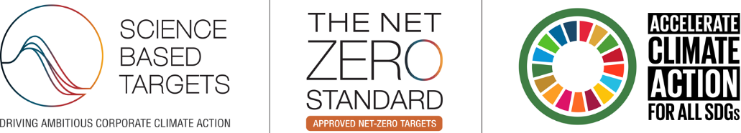

EXAMPLES OF KEY RESPONSIBILITIES:

- Development of services to existing clients and engaging with / bringing on new clients
- Conduct energy audits on a range of different building types including offices, industrial premises and data centres
- Provide gap analyses on and implement ISO50001 EnMS
- Prepare life cycle cost analyses on different projects
- Develop robust spreadsheet / software based energy scenario models to support the development of energy and decarbonisation / carbon management strategies for clients with large portfolios of buildings
- Prepare energy and sustainability statements to support planning applications for new developments
- Leading the development and delivery of sustainable certifications, TCFD / TNFD and SBTi planning, ethical audits (SMETA), Net Zero Strategies, Circular Economy plans and associated ESG reporting
- Coordinating frameworks, bids and sub-contractors
- Lead business development activities and quotations for new work
- Provide a sounding board through Technical Review activities and being a central member of the team
- Conduct options analyses and specify energy efficient and low carbon buildings and technologies
- Develop renewable energy technology feasibility studies
- Carry out project management and administration tasks, manage smaller projects and work towards an associated enhanced professional qualification (e.g. Chartered Energy Manager)

KEY PERFORMANCE INDICATOR AREAS:

- Superb delivery of the services and projects resulting in the meeting of and wherever possible, exceeding client expectations
- Communicate timely, accurate management information and solutions
- Collaborate effectively with internal / external team members in a flat structure
- Provide regular opportunity analyses to help shape the company direction and strategy
- Help drive profitable revenue growth as an integral part of the company’s future plans

Person Specification
IDEAL KNOWLEDGE

- Understanding of BREEAM, LEED and WELL accreditation
- Minimum of 7+ years’ relevant work experience in energy and/or sustainability consulting or related field
- Communicating detailed energy / sustainability concepts in industrial / data centre environments
- Understanding of optimisation, digitalisation and smart technologies around building sustainability
- Experience of carbon foot-printing and embodied carbon analysis

PERSONAL SKILLS AND ABILITIES

- High level of commitment and an independent, conceptual working style
- Ability to quickly understand complex problems and develop solutions
- Superb written, numerical and oral communication skills
- Enjoys developing new concepts in collaborative environment
- Willingness to travel/flexibility to work on international projects if required
- Ambitious with desire to continue learning and developing expertise / accreditations
- Committed to continual improvement and customer satisfaction
- Superb Team member but self-driven
- Highly flexible and adaptable to a wide variety of project requirements
IDEAL QUALIFICATIONS AND EXPERIENCE

- Qualified to degree level in related background; Minimum 2:1
- Hold a Master’s or advanced related Professional qualification
- Qualified Energy Auditor and certified ISO50001 professional

Please apply in writing with a CV and Cover Letter using the Web Form

